## Session 1. Quiz: Missing Parameters

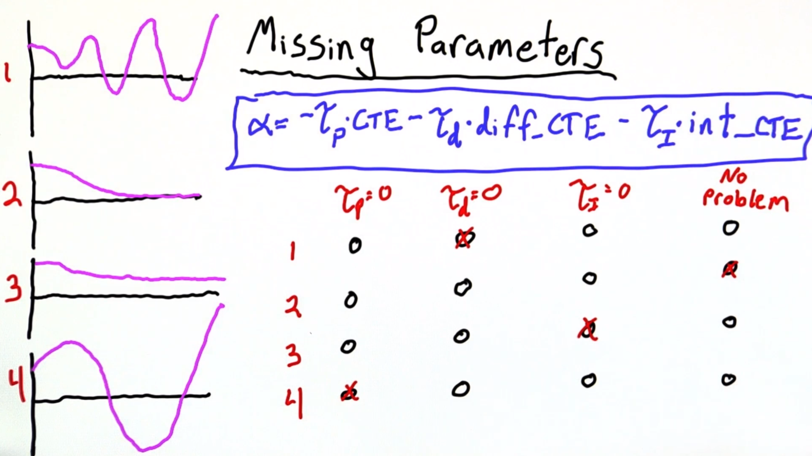

Number 3 we're reaching the steady state where the robot's upward drift is being balanced by its downward tendency caused the , and though we reach some sort of steady state, it's not the steady state we want. This is due to we missing the integral portion or the integral is too small.

The key to understanding number 4 was realizing that the robot starts by moving upwards. This is the only case for the robot started going up, and what's happening here is the drift is dominating since the Proportional is equal to 0, there is no initial term that steers the robot towards the goal, and without that, the drift is going to take over. Of course, as we accumulate error that gets corrected for and we steer down, but eventually we get into this sort of oscillating behavior.

The oscillations are not as frequent, however, as they are in case number 1.

If we think of this Differential CTE term as a sort of smoothing term, which damps out these wild oscillations. Then we can see how, if Derivative is equal to 0, we would expect these sort of growing oscillations, and this behavior is characteristic of any PID controller where the Differential term is too small.